

Screen Sharing with Collage

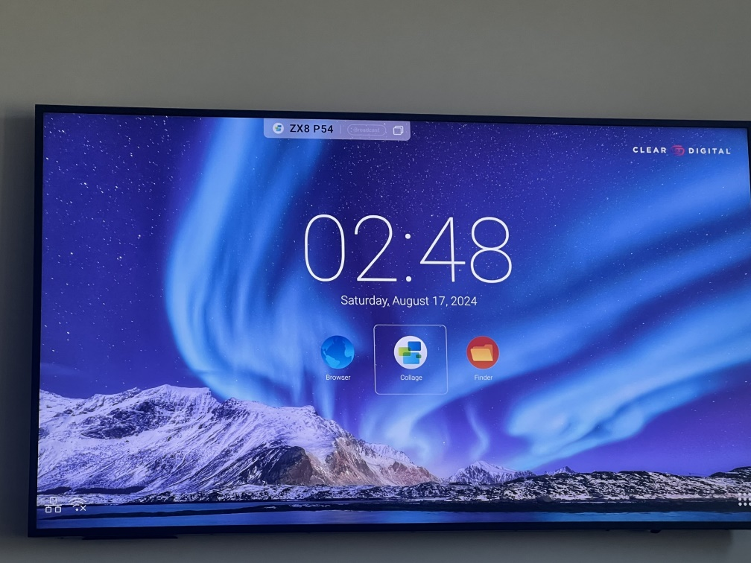Turn on both the Cleartouch Monitor with the power button on the bottom right and Front TV using the TV Remote on the desk. When the TV is on, go to the Collage App in the middle of the screen using the TV Remote.

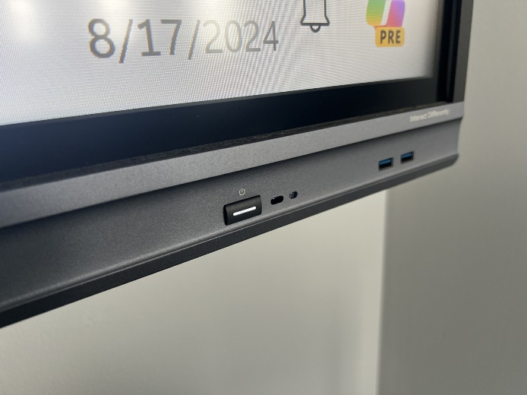

Turn on the two TVs on the back wall using the same TV Remote and open the Collage App on those as well. Return to the Front TV and click Menu 🡪 Screen Group.

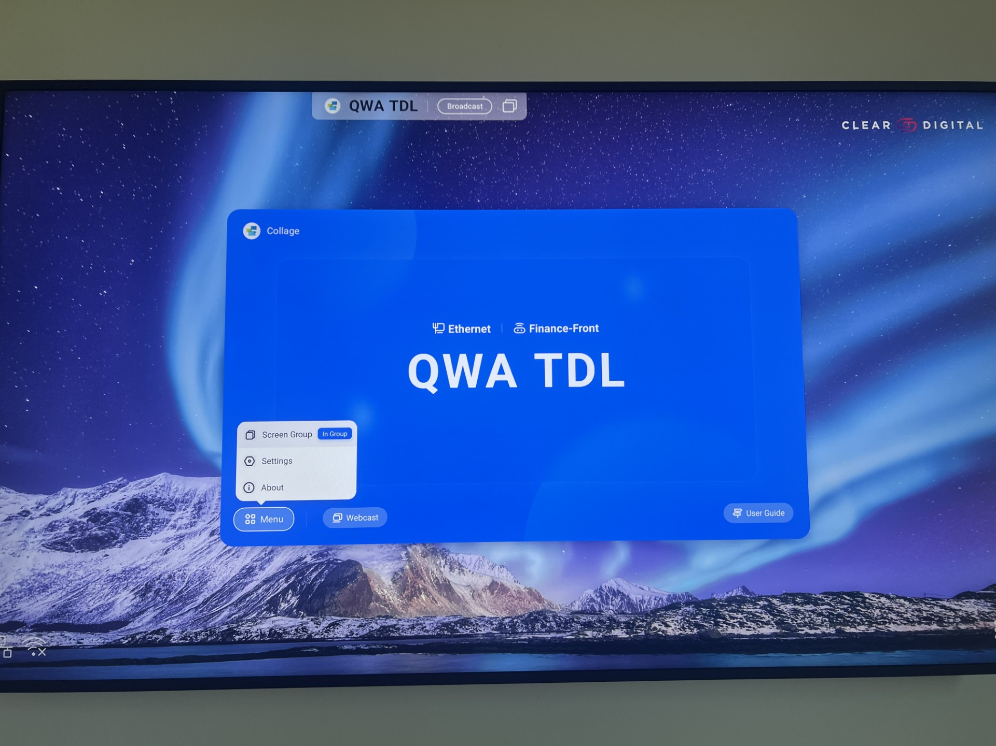

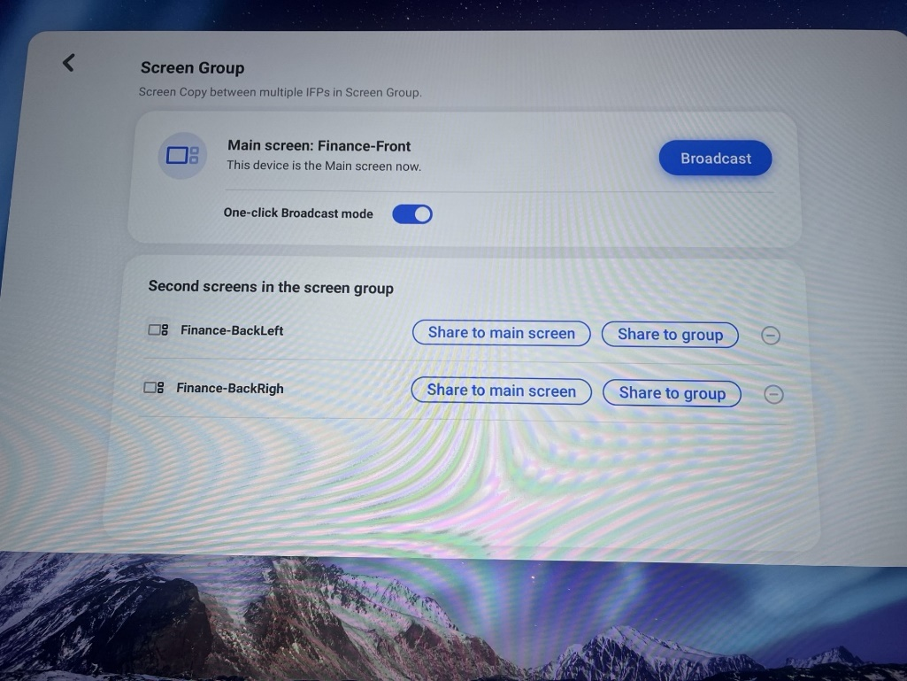On the Screen Group page, click Broadcast. This will sync the Back TV’s screens to the Front TV. Head back to the main screen with the six-character code.

Go to the Cleartouch Monitor behind the desk, and using the keyboard and mouse, click on the Collage App on the Desktop. Type in the six-character code that is displayed on the Front TV screen.

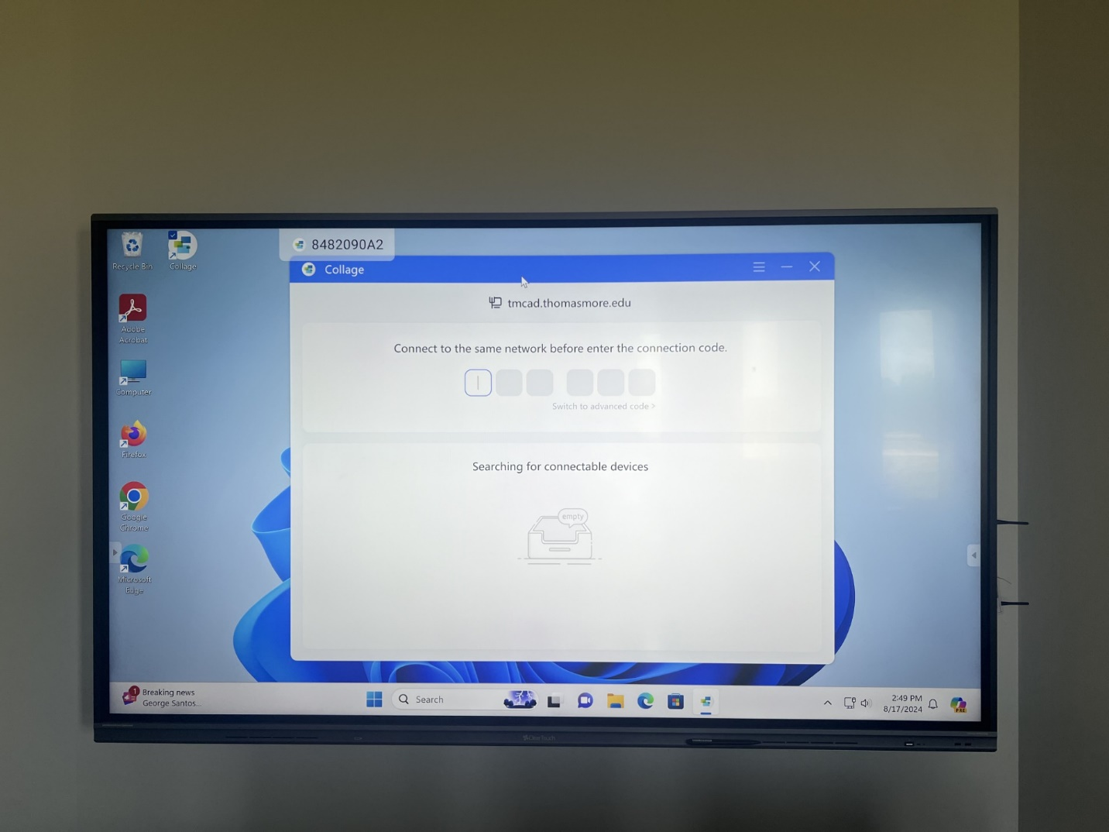

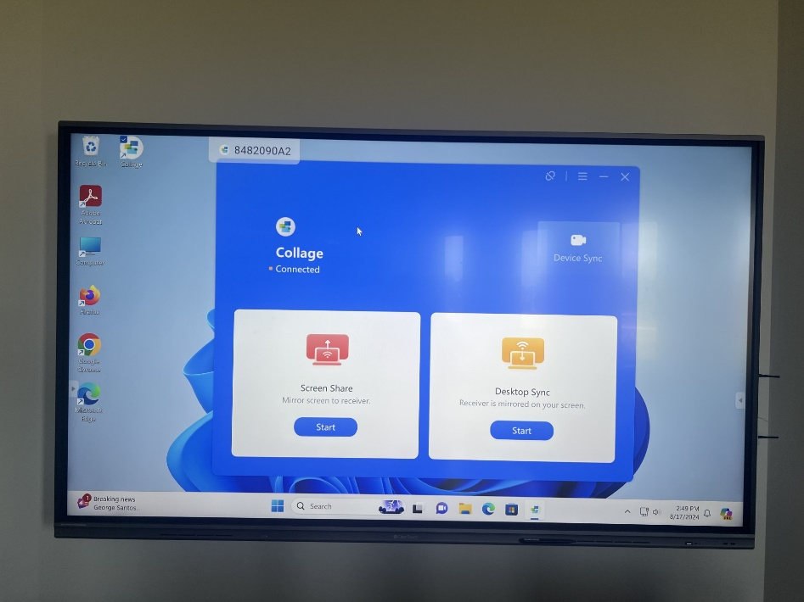A menu with two options will appear. Click **Start** underneath the one on the left: **Screen Share**

Next, Select Mirror. This will sync the TV screens to the computer screen.

